***Comparative Analysis of DenseNet, ResNet, and Xception on Potato Health Detection***



**Project Overview**  
This project investigates the use of deep learning techniques for classifying potato plant conditions using the PlantVillage dataset. The focus is on three specific classes: **Potato___Early_blight**, **Potato___Late_blight**, and **Potato___healthy**. To achieve this, three models—**DenseNet**, a custom **ResNet** (implemented from scratch), and **Xception**—are developed and evaluated. By comparing their performance, the study aims to identify the most effective architecture for accurate plant disease diagnosis, contributing to advancements in precision agriculture and plant health management.

1. **Introduction to DenseNet**



DenseNet, introduced in the paper *"Densely Connected Convolutional Networks"* (Huang et al., CVPR 2017), is an architecture known for its efficiency in parameter usage. It improves information flow by connecting each layer to every other layer, ensuring feature reuse. This is achieved through **dense blocks** that concatenate outputs instead of summing them (as in ResNet).

**Key Reference:**

* Paper: [Densely Connected Convolutional Networks](https://arxiv.org/abs/1608.06993)

**1. Step-by-Step Explanation of Code**

**a. Data Loading and Preprocessing**

* **Dataset Creation**: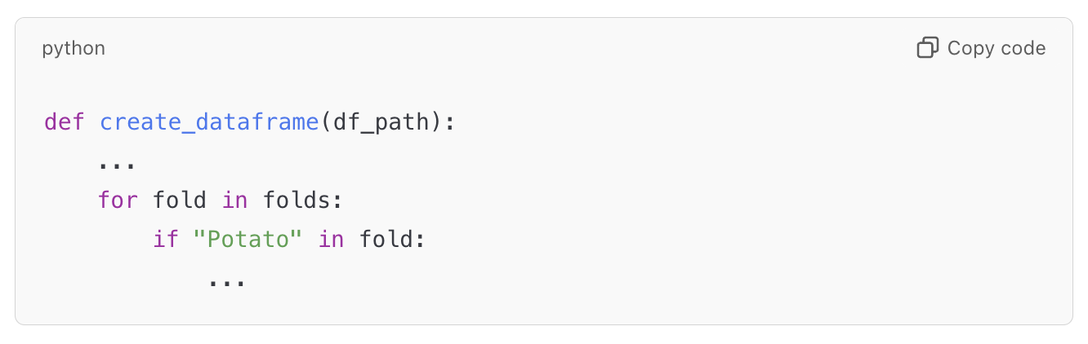

The code processes subdirectories containing "Potato" images, creating a DataFrame with file paths and labels.

* **Data Splitting**: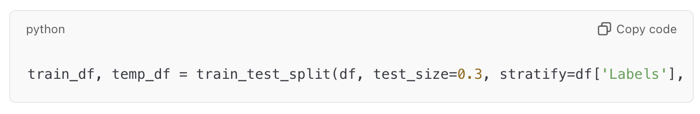The dataset is split into training, validation, and test sets, maintaining class balance using stratify.
* **Augmentation and Generators**: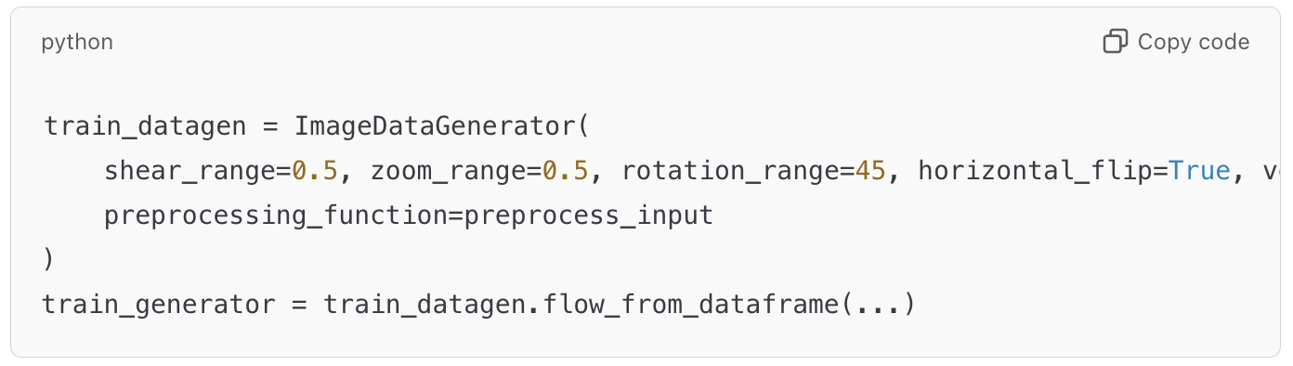The ImageDataGenerator applies data augmentation (rotation, flipping, etc.) and uses preprocess_input for DenseNet.

**b. Model Architecture**

* **DenseNet Base**: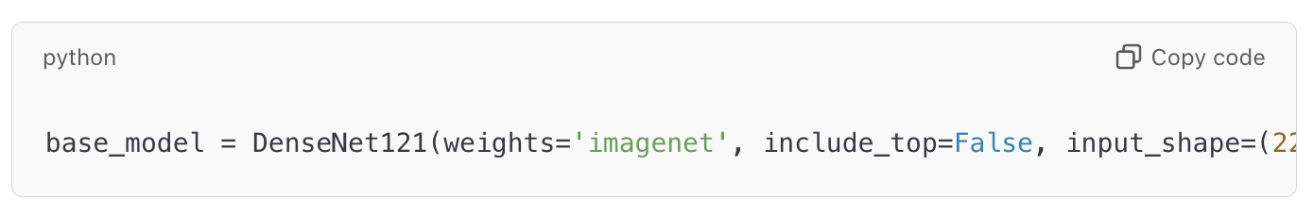The pre-trained DenseNet121 is loaded without its top layers. This serves as a feature extractor.
* **Custom Head**: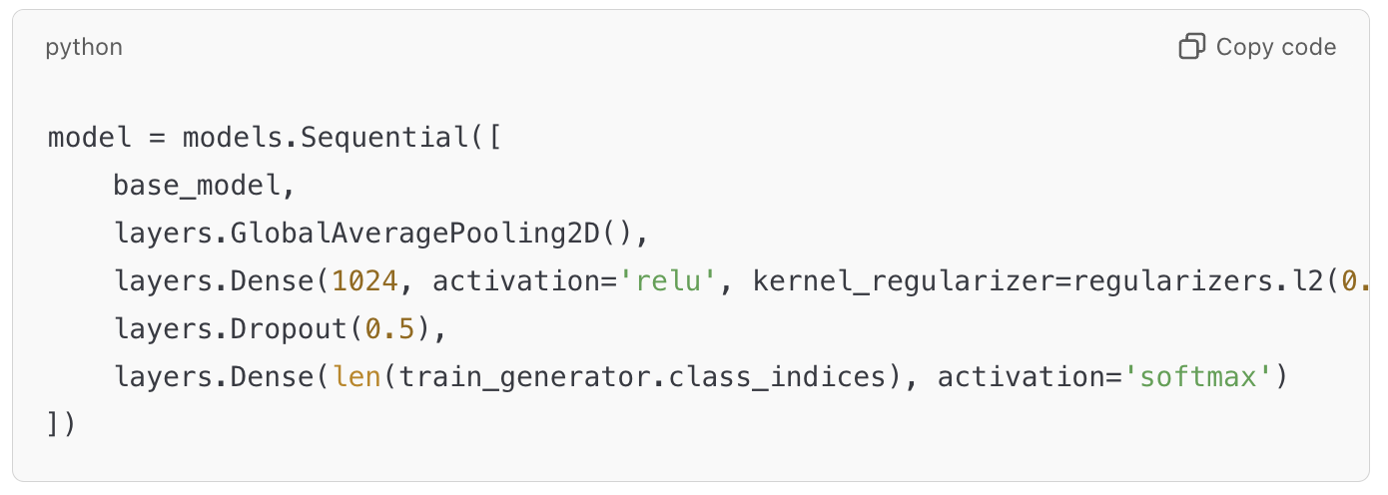
  + **GlobalAveragePooling2D**: Reduces the spatial dimensions of the feature maps.
  + **Dense Layer**: Adds a fully connected layer with L2 regularization to prevent overfitting.
  + **Dropout**: Randomly drops neurons during training, reducing overfitting.
  + **Output Layer**: Softmax layer for multi-class classification.

**c. Training**

* **Compiling the Model**: 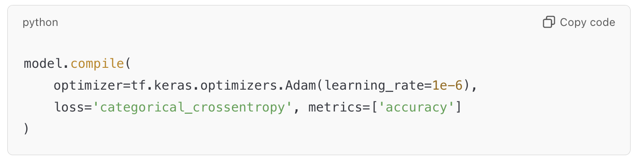Uses a low learning rate for fine-tuning the pre-trained model.
* **Early Stopping and Checkpointing**: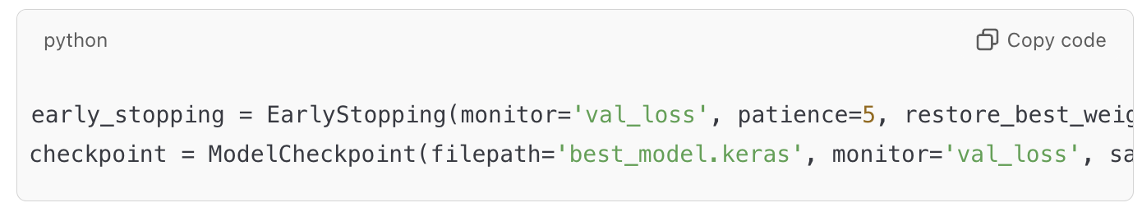Prevents overfitting by stopping early if validation loss doesn’t improve.

**d. Evaluation**

* **Accuracy and Loss**: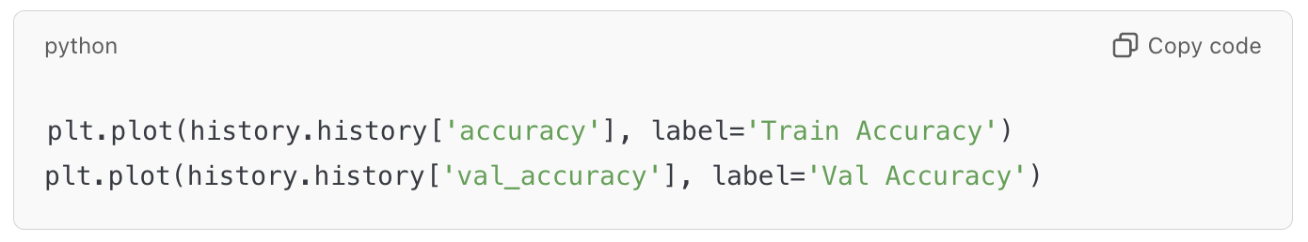Plots training and validation metrics over epochs to visualize model performance.
* **Confusion Matrix**: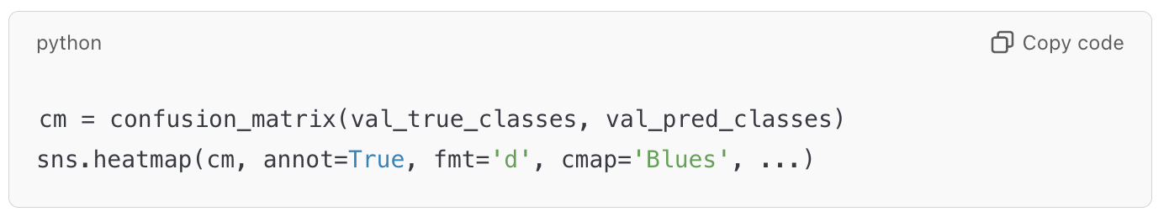Evaluates model predictions class-wise.
* **ROC Curve and AUC**: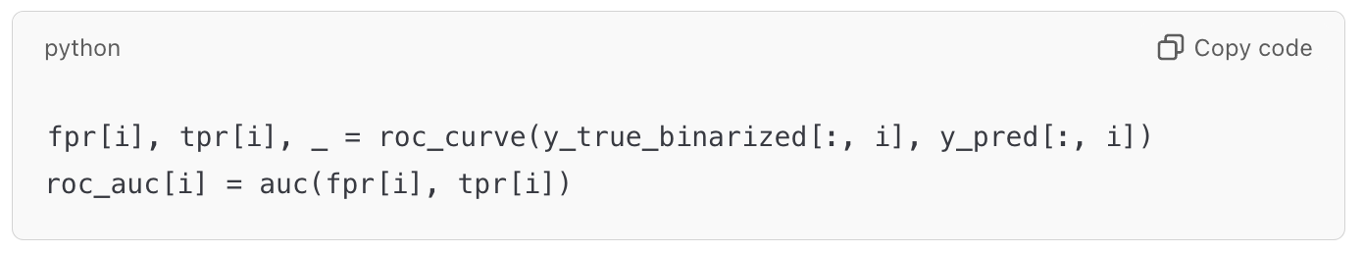Measures how well the model distinguishes between classes.

**e. Fine-Tuning**

* **Unfreezing Layers**: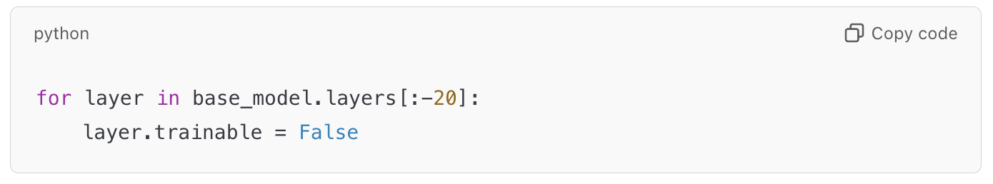Gradually unfreezes layers for fine-tuning, starting with the last 20 layers.
* **Class Weights**: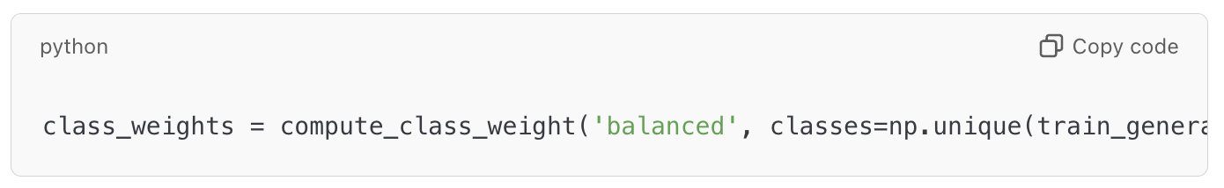Balances class distribution in the loss function to handle imbalance in the dataset.

**2. Key Concepts of DenseNet**

**1. Dense Connectivity**

* Unlike traditional CNNs where each layer passes its output only to the next layer, in DenseNet, **each layer receives input from all previous layers** and passes its output to all subsequent layers.
* This dense connectivity allows better feature reuse and reduces the problem of vanishing gradients.
* If there are *L* layers, each layer has *L(L+1)/2* direct connections.

**2. Growth Rate (kk)**

* The **growth rate** is the number of output feature maps (channels) each layer produces.
* For example, if *K*= 32, each layer contributes 32 feature maps to subsequent layers.
* This keeps the network compact because the number of new feature maps added is controlled by *K*.

**3. Bottleneck Layers**

* To reduce computational complexity, DenseNet uses a **bottleneck layer** (1x1 convolution) before the main convolution in each dense block. This reduces the number of input feature maps.

**4. Compression**

* To further reduce the size of the network, DenseNet employs a **transition layer** between dense blocks. These layers perform down-sampling using 1X1 convolutions followed by pooling.

**5. Dense Blocks**

* The network is divided into **dense blocks**, where the dense connectivity is implemented.
* Each block is followed by a **transition layer** (except the last one), which reduces the spatial dimensions and the number of feature maps.

**DenseNet Architecture**

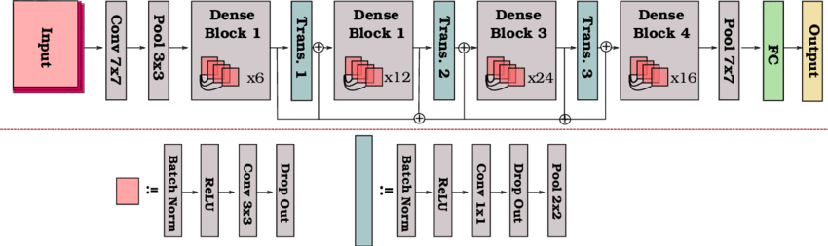

The architecture can be summarized as follows:

1. **Input Layer**:
   * A 7 x 7 convolution followed by a max-pooling operation to reduce spatial dimensions.
2. **Dense Block**:
   * A dense block is a sequence of layers where each layer receives input from all previous layers and contributes its output to the subsequent layers.
   * Each layer consists of:
     + Batch Normalization (BN)
     + ReLU activation
     + 1 x 1 Convolution (bottleneck layer)
     + Batch Normalization (BN)
     + ReLU activation
     + 3 x 3 Convolution
   * The outputs of all layers are concatenated along the feature dimension.
3. **Transition Layer**:
   * Between dense blocks, a transition layer reduces the number of feature maps using 1 x 1 convolution and down-samples the feature maps using 2 x 2 average pooling.
4. **Growth Rate** (*K*):
   * Determines how many new feature maps are added by each layer in a dense block.
   * If the initial number of feature maps is *F0*, and the block has *L* layers, the final number of feature maps will be *F0* + *K* × L
5. **Classification Layer**:
   * At the end of the network:
     + Global average pooling (reduces spatial dimensions to 1x1).
     + Fully connected layer with softmax activation for classification.

**DenseNet Variants**

DenseNet has several variants depending on the depth of the network:

* **DenseNet-121** (used in my project): Has 121 layers.
* **DenseNet-169**
* **DenseNet-201**
* **DenseNet-264**

The numbers (121, 169, etc.) indicate the total number of layers, including the dense blocks and transition layers.

**3. Graphs**

***-MODEL ACCURACY AND LOSS CURVE BEFORE FINE-TUNING***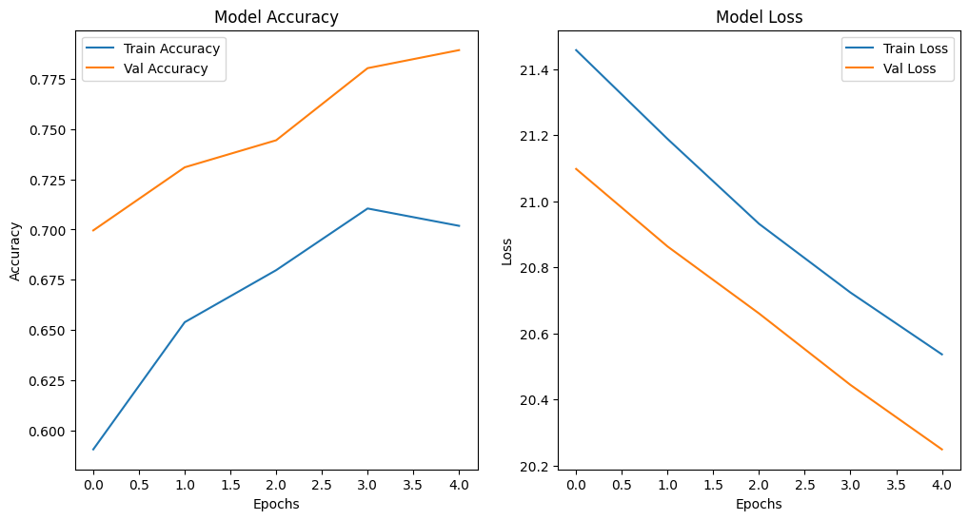

***-MODEL ACCURACY AND LOSS CURVE AFTER FINE-TUNING***

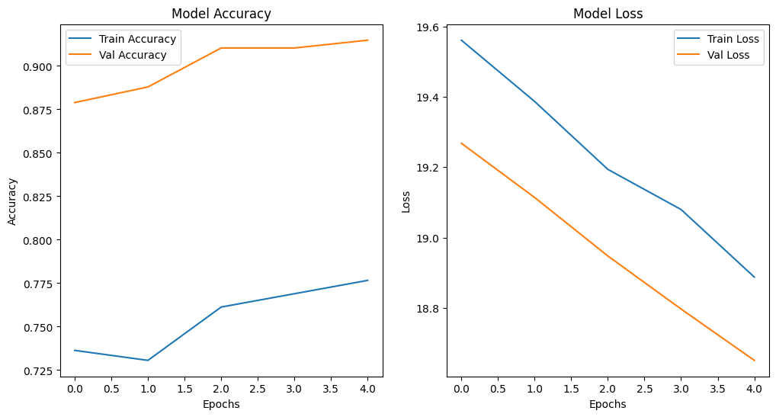

***-MODEL (precision, recall, f1-score, confusion matrix) BEFORE FINE-TUNING***

precision recall f1-score support

Potato___Early_blight 1.00 0.12 0.21 50

Potato___Late_blight 0.69 1.00 0.82 150

Potato___healthy 0.00 0.00 0.00 23

accuracy 0.70 223

macro avg 0.56 0.37 0.34 223

weighted avg 0.69 0.70 0.60 223

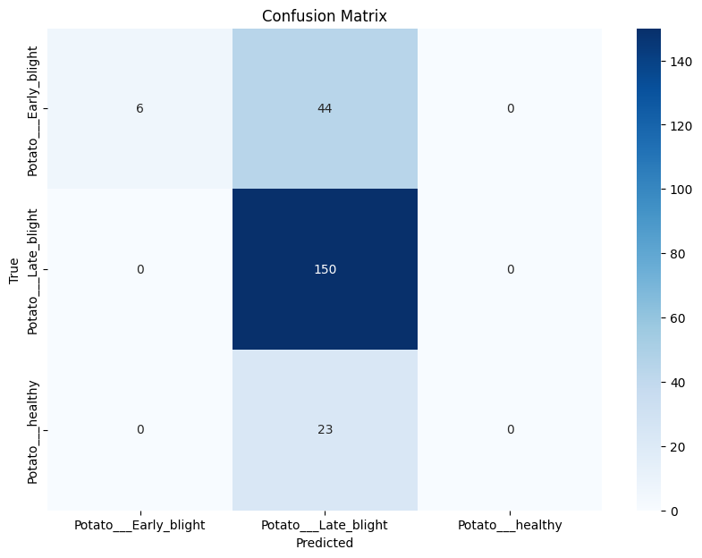

***-MODEL (precision, recall, f1-score, confusion matrix) AFTER FINE-TUNING***

precision recall f1-score support

Potato___Early_blight 0.66 0.82 0.73 50

Potato___Late_blight 0.83 0.76 0.79 150

Potato___healthy 0.26 0.26 0.26 23

accuracy 0.72 223

macro avg 0.58 0.61 0.59 223

weighted avg 0.73 0.72 0.72 223

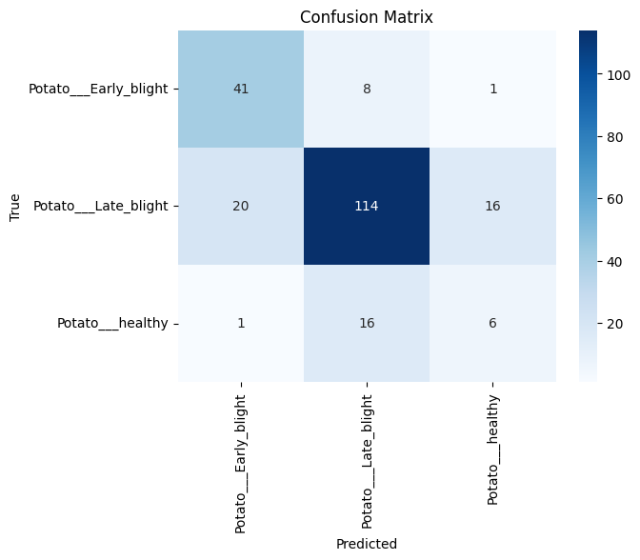

***-MODEL ROC AND AUC BEFORE FINE-TUNING***

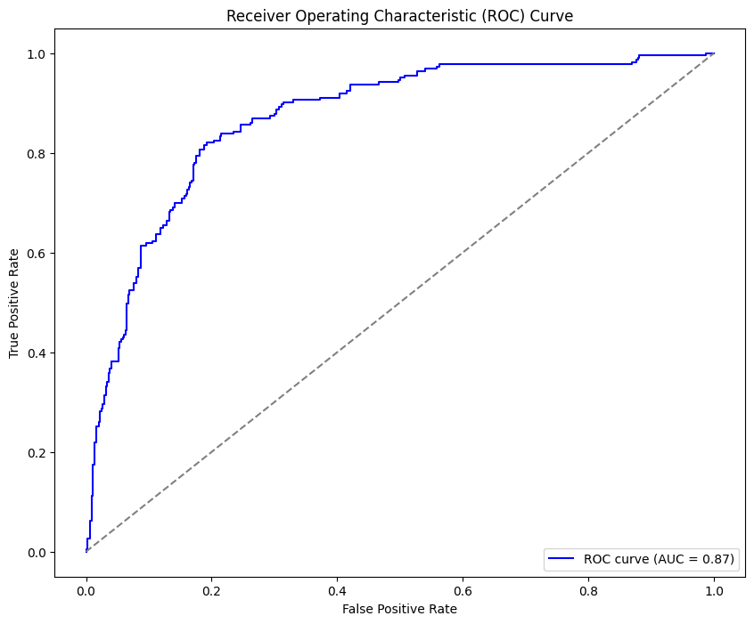

***-MODEL ROC AND AUC AFTER FINE-TUNING***

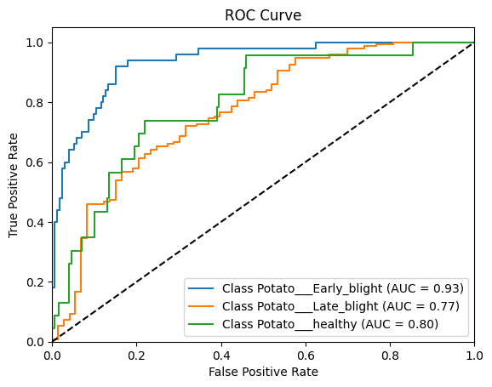

**4. Enhancements**

* **Learning Rate Scheduling**: Introduce dynamic learning rate adjustments (e.g., ReduceLROnPlateau).
* **Batch Normalization Tuning**: Adjust BatchNorm layers for better convergence.
* **Data Augmentation**: Use more advanced augmentation techniques (e.g., CutMix or MixUp).
* **Ensemble Learning**: Combine DenseNet predictions with other models for improved results.

1. **Introduction to ResNet**



ResNet (Residual Network), introduced in the paper *"Deep Residual Learning for Image Recognition"* (He et al., CVPR 2016), is a groundbreaking architecture that mitigates the vanishing gradient problem through residual connections. These connections allow the network to learn identity mappings more effectively, enabling the training of very deep models.

**Key Reference:**

* Paper: [Deep Residual Learning for Image Recognition](https://arxiv.org/abs/1512.03385)

**1. Step-by-Step Explanation of Code**

**a. Data Loading and Preprocessing**

* **Dataset Creation**: The dataset is loaded using TensorFlow's 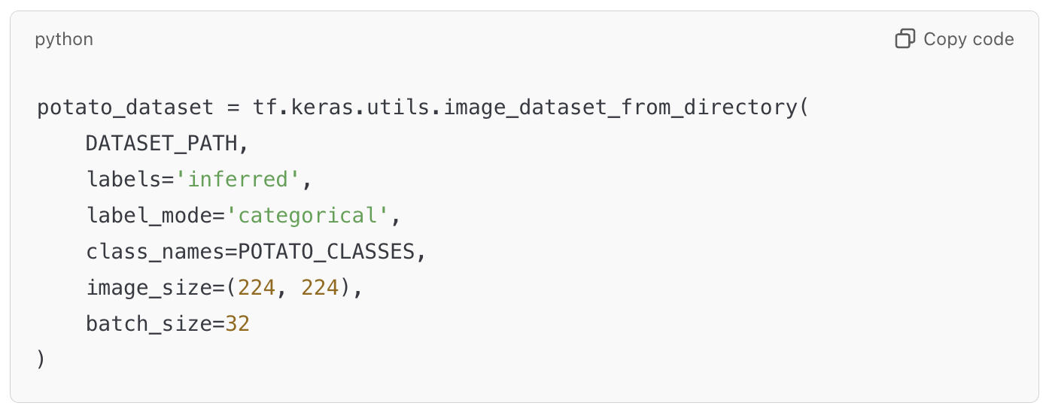
* **Data Splitting**: The dataset is split into training and validation sets: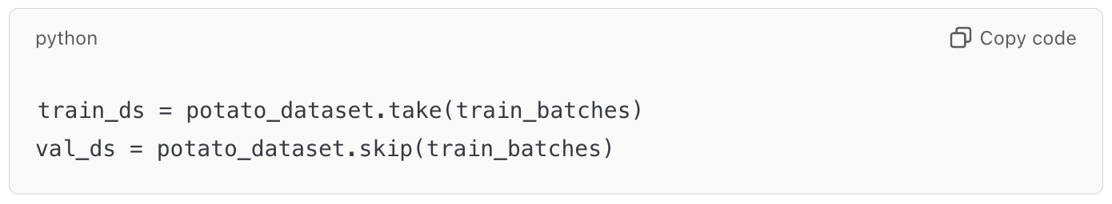
* **Data Augmentation**: Basic augmentation techniques, such as horizontal flipping and random rotations, are applied directly within the model: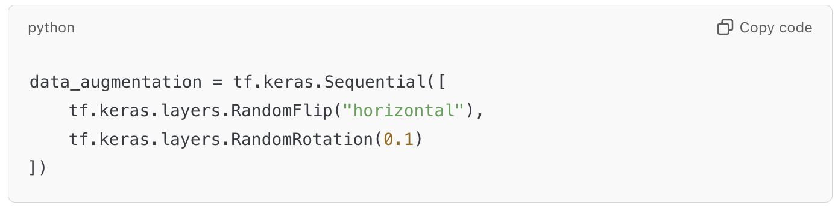

**b. Model Architecture**

The ResNet model consists of several key components that work together to extract hierarchical features from the input images. The architecture is built using residual blocks, which help mitigate the vanishing gradient problem and improve training efficiency. Below is a breakdown of the components:

**1. Initial Convolutional Layer:**

* The model starts with a **7x7 convolution** with a stride of 2. This large kernel size captures low-level features (edges, textures) and reduces the spatial dimensions of the input early in the network.
* The convolutional layer is followed by **batch normalization**, which normalizes activations to stabilize and speed up training.
* A **ReLU activation function** introduces non-linearity to enable the model to learn complex patterns.
* Finally, a **3x3 max-pooling** operation further reduces the spatial dimensions and retains the most important features: 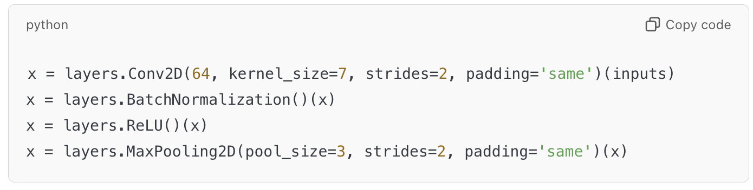

**2. Residual Blocks:**

* Residual blocks are the building blocks of ResNet. Each block consists of:
  + Two **3x3 convolutional layers**.
  + **Batch normalization** after each convolution to normalize activations.
  + **ReLU activation** after the first convolution.
* The core idea of a residual block is to allow the input (shortcut connection) to bypass the block's layers and be directly added to the block's output: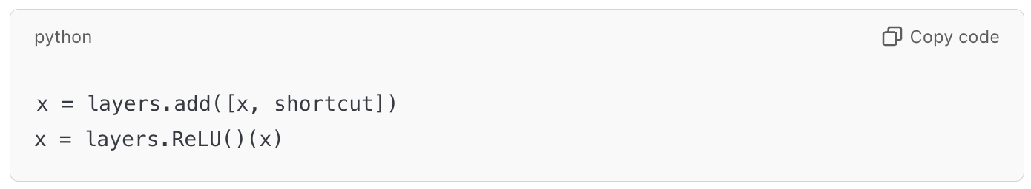
* This skip connection ensures gradients can flow through the network more easily, mitigating the vanishing gradient problem and allowing the model to learn identity mappings when necessary.

**3. Projection Shortcut:**

* When the dimensions of the input and output do not match (e.g., due to a stride of 2), a **projection shortcut** is used to transform the input dimensions. This is achieved via a **1x1 convolution**: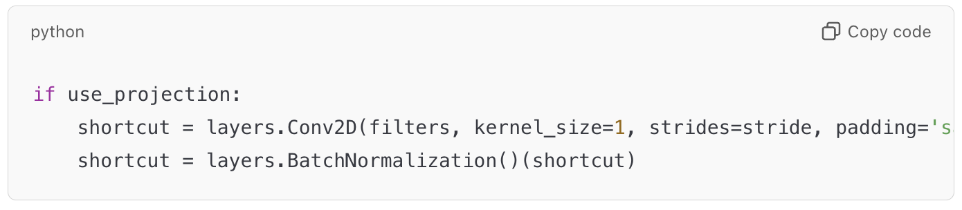
* The projection ensures that the dimensions of the shortcut connection match the output of the block, enabling the addition operation.

**4. Stacking Residual Blocks:**

* The architecture stacks multiple residual blocks, increasing the number of filters at each stage. This hierarchical design allows the model to extract increasingly complex features at deeper layers.
* The stages in this implementation are as follows:
  + **Stage 1**: Two residual blocks with 64 filters.
  + **Stage 2**: Two residual blocks with 128 filters, with the first block using a stride of 2 for downsampling.
  + **Stage 3**: Two residual blocks with 256 filters, with the first block using a stride of 2 for downsampling.
  + **Stage 4**: Two residual blocks with 512 filters, with the first block using a stride of 2 for downsampling.

**5. Global Average Pooling:**

* After the final residual block, the spatial dimensions of the feature maps are reduced to a single value per feature map using **global average pooling**: 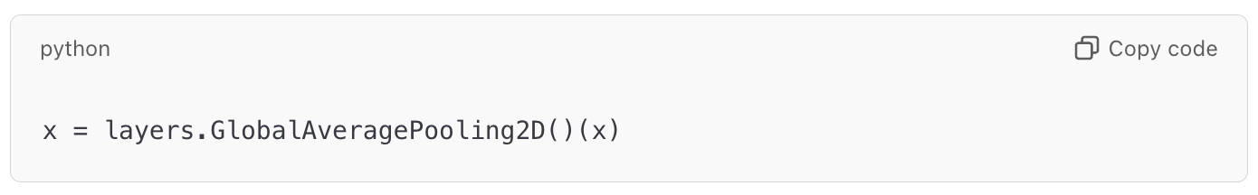
* This operation drastically reduces the number of parameters and ensures the model retains only the most important features.

**6. Fully Connected Layer and Dropout:**

* The pooled features are passed to a **dense layer** with softmax activation for classification into three classes.
* A **dropout layer** with a rate of 0.5 is used before the dense layer to prevent overfitting by randomly disabling neurons during training: 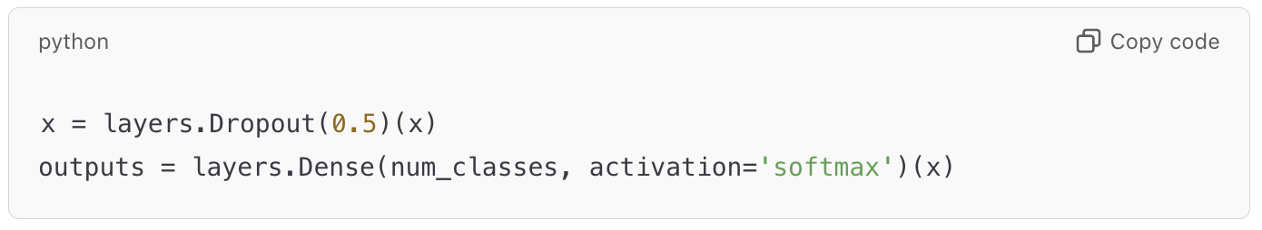

**Key Highlights of the Architecture:**

* **Depth:** The model uses 8 residual blocks, making it comparable to ResNet-18 in terms of design simplicity.
* **Efficiency:** The use of skip connections ensures efficient gradient flow, allowing the model to train deeper architectures without degradation.
* **Regularization:** Dropout and batch normalization minimize overfitting and improve generalization.
* **Feature Hierarchy:** The increasing number of filters at each stage enables the model to learn more abstract and complex features as the network deepens.

**c. Training**

* **Model Compilation**: The model is compiled with the Adam optimizer and a low learning rate: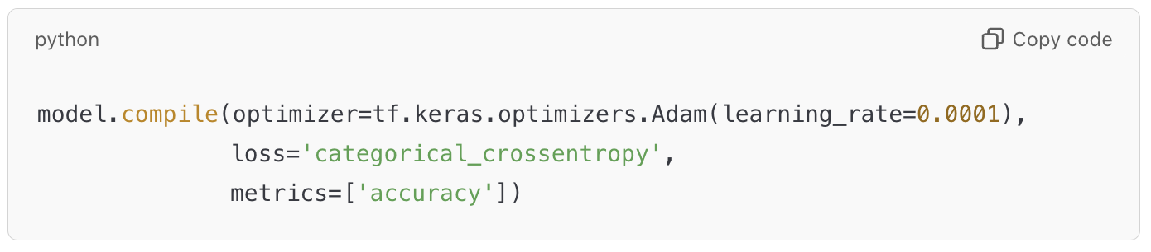
* **Callbacks**: Early stopping and model checkpointing are used to prevent overfitting and save the best model: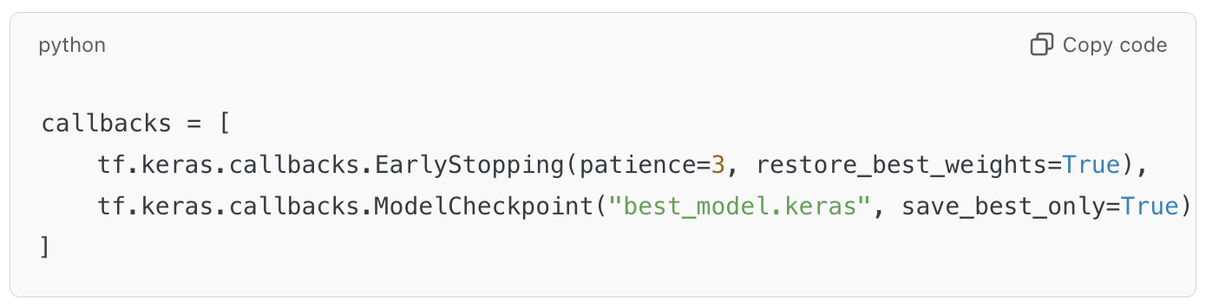
* **Training**: The model is trained for 10 epochs with validation data: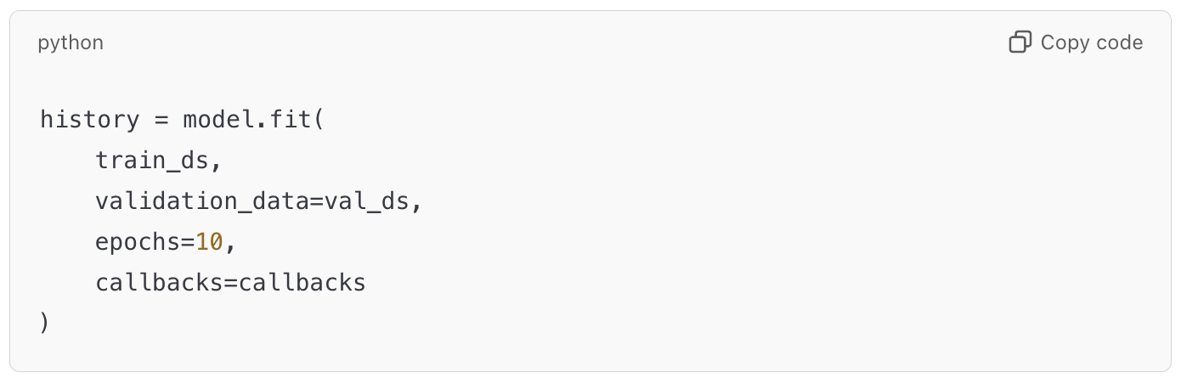

**d. Evaluation**

* **Accuracy and Loss**: Plot training and validation metrics over epochs to visualize the model's performance: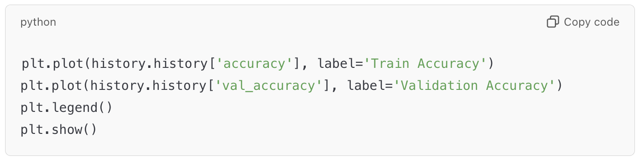
* **Confusion Matrix**: Use a confusion matrix to evaluate class-wise predictions.
* **ROC Curve and AUC**: Measure the model's ability to distinguish between classes using ROC curves and AUC scores.

**2.** **Key Concepts of ResNet**

**1. Residual Connections (Skip Connections)**

* The core idea of ResNet is that instead of learning a direct mapping from input to output, the network learns the **residual** or difference between the input and the output.
* Mathematically, the output of a layer *l* is expressed as:



where:

* + 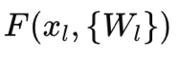is the learned transformation (the residual function).
  + 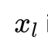 is the input to the layer (the identity or skip connection).
  + The output *yl* is the sum of the learned transformation and the input.
* This skip connection allows gradients to flow more easily during backpropagation, making it easier to train deeper networks.

**2. Identity Mapping**

* The residual connection typically adds the input *xl* directly to the output of the transformation .This helps the model learn an identity mapping in cases where it's easier for the model to predict the input than to learn a complex transformation.

**3. Building Blocks of ResNet**

* The ResNet architecture is built using **residual blocks**. Each residual block consists of a few convolutional layers, and the input is added to the output before passing through the activation function.
* **Basic Block**: A simple residual block used in smaller networks (like ResNet-18).
* **Bottleneck Block**: A more complex residual block used in deeper networks (like ResNet-50, ResNet-101, etc.), which consists of three convolutions, reducing the number of feature maps in the middle layer.

**4. Bottleneck Structure**

* In deeper versions of ResNet (e.g., ResNet-50, ResNet-101), a **bottleneck structure** is used in the residual blocks. It involves:
  + A **1x1 convolution** that reduces the number of feature maps.
  + A **3x3 convolution** that applies the transformation.
  + Another **1x1 convolution** that restores the number of feature maps to the original size.
* This bottleneck design helps reduce the computational cost of the network while maintaining the depth.

**5. Global Average Pooling**

* ResNet uses **global average pooling** at the end of the network to reduce the spatial dimensions to 1x1, followed by a fully connected layer for classification.
* This helps reduce the total number of parameters and increases computational efficiency.

**ResNet Architecture**

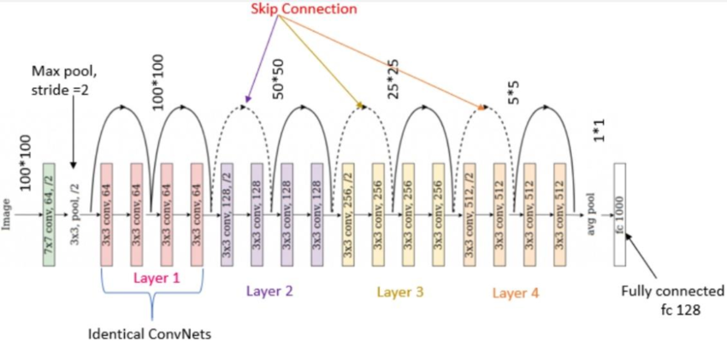

The architecture can be broken down into the following layers:

1. **Input Layer**
   * Input image: typically 224 × 224 × 3 for standard ImageNet tasks.
2. **Initial Convolution**
   * A 7 × 7 convolution with stride 2, followed by a **MaxPooling** layer with a 3 × 3 kernel and stride 2. This reduces the spatial dimensions early on.
3. **Residual Blocks**
   * The core of ResNet consists of multiple residual blocks stacked on top of each other.
   * The network is divided into several groups of residual blocks:
     + **ResNet-18** and **ResNet-34**: Use **basic blocks**.
     + **ResNet-50**, **ResNet-101**, and **ResNet-152**: Use **bottleneck blocks**.
   * The residual blocks are grouped into stages, each stage containing multiple blocks. The number of blocks in each stage increases as the network deepens:
     + **Stage 1**: 64 filters, followed by 3×33 \times 3 convolutions.
     + **Stage 2**: 128 filters.
     + **Stage 3**: 256 filters.
     + **Stage 4**: 512 filters.
4. **Identity and Convolutional Blocks**
   * Within each residual block, we either add an identity shortcut connection (for basic blocks) or a convolutional shortcut (for bottleneck blocks) to match the dimensions.
5. **Final Classification**
   * After the residual blocks, a **global average pooling** layer is applied to reduce the spatial dimensions to 1 × 1.
   * Finally, a fully connected (FC) layer is applied with a softmax activation function for classification.

**Conclusion**

ResNet's innovative use of residual connections allows it to train deeper networks with improved gradient flow, making it a powerful architecture for a wide range of tasks, including image classification and object detection. It has achieved state-of-the-art performance on many benchmarks, including ImageNet.

If you need more specific details or comparisons with other models like DenseNet and Xception, feel free to ask!

1. **Graphs**

***-MODEL ACCURACY AND LOSS CURVE***

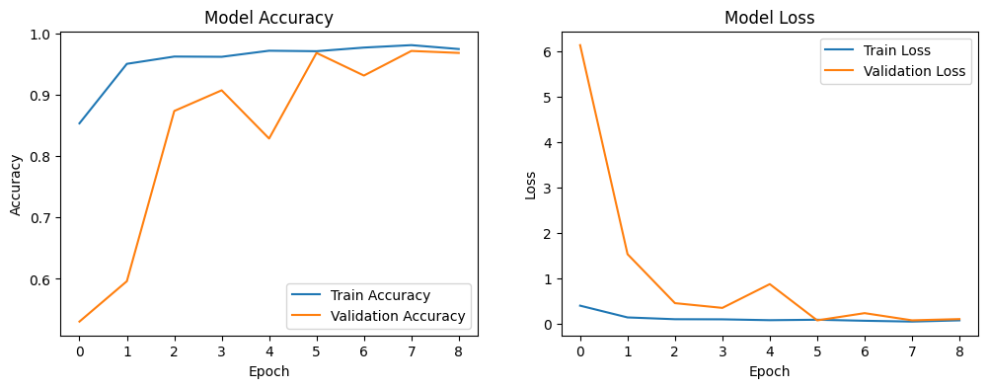

***-MODEL PRECISION, RECALL, F1-SCORE***

precision recall f1-score support

Potato___Early_blight 0.96 1.00 0.98 202

Potato___Late_blight 0.98 0.92 0.95 190

Potato___healthy 0.97 0.99 0.98 232

accuracy 0.97 624

macro avg 0.97 0.97 0.97 624

weighted avg 0.97 0.97 0.97 624

***-MODEL CONFUSION MATIX***

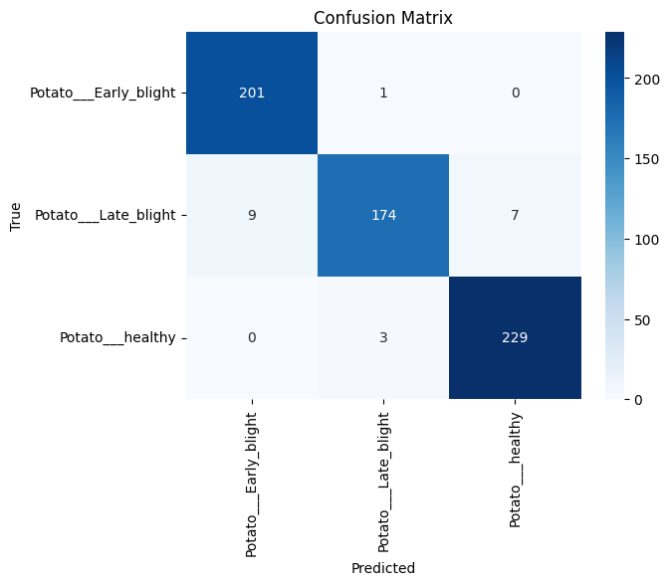

***-MODEL ROC AND AUC CURVE***

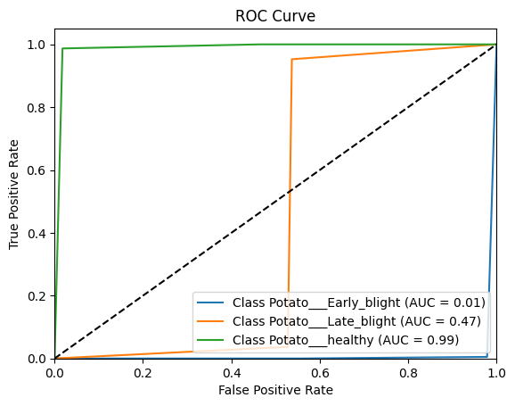

**4. Enhancements**

* **Learning Rate Scheduling**: Use ReduceLROnPlateau to dynamically adjust the learning rate based on validation loss.
* **Advanced Data Augmentation**: Incorporate advanced techniques like CutMix or MixUp for better generalization.
* **Class Weights**: Handle class imbalance by assigning weights to the loss function.
* **Ensemble Learning**: Combine ResNet with other models to improve classification accuracy.

1. **Introduction to Xception**



Xception (Extreme Inception), introduced by François Chollet in 2017, is a deep convolutional neural network based on depthwise separable convolutions. It is an improvement over Inception models, offering superior performance with fewer parameters.

**Key Features:**

1. **Depthwise Separable Convolutions:** Reduces computation while improving performance.
2. **Pre-trained on ImageNet:** Provides a strong starting point for transfer learning.
3. **Global Average Pooling:** Minimizes the number of parameters.

**Key Reference:**

* Paper: [Xception: Deep Learning with Depthwise Separable Convolutions](https://arxiv.org/abs/1610.02357)

**3. Step-by-Step Explanation of Code**

**a. Data Preparation**

* **Create DataFrame**: The dataset is read from directories and stored in a DataFrame, with each row representing the image path and its corresponding label: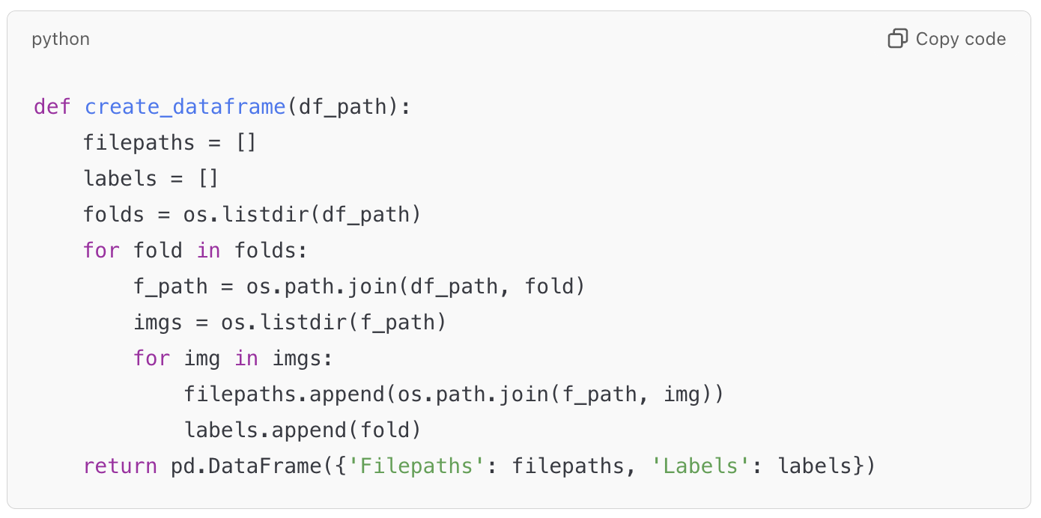
* **Filter Specific Classes**: Only images of the specified classes (Potato___Early_blight, Potato___Late_blight, and Potato___healthy) are included: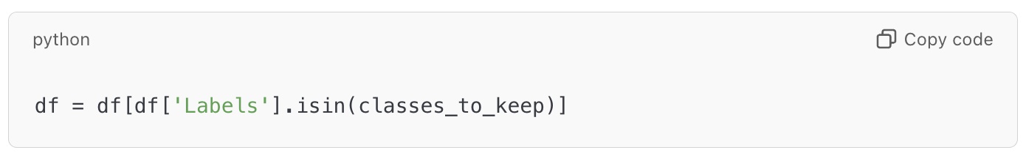
* **Split Data**: The dataset is split into training, validation, and test sets using stratified sampling to maintain class balance: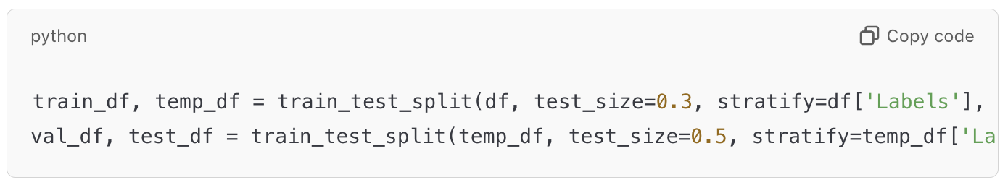

**b. Data Preprocessing**

* **Data Augmentation**: Image augmentation techniques are applied during training to improve generalization: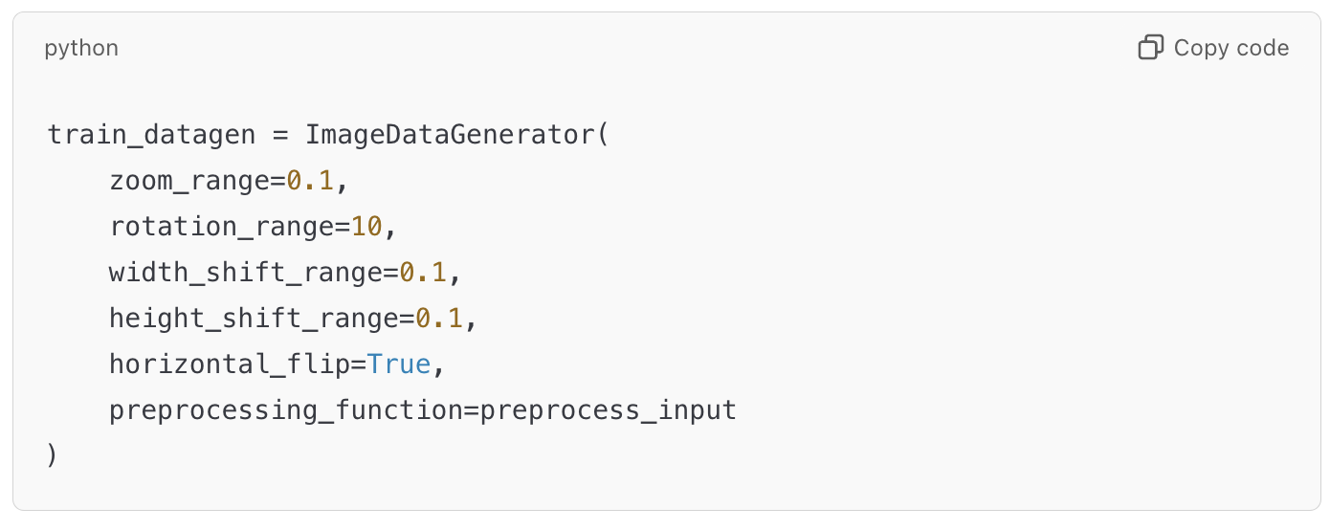
* **Preprocessing for Validation/Test**: Only normalization using Xception's preprocessing function: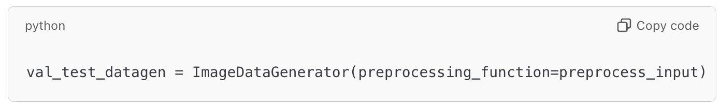
* **Flow from DataFrame**: Data is fed into the model using TensorFlow generators: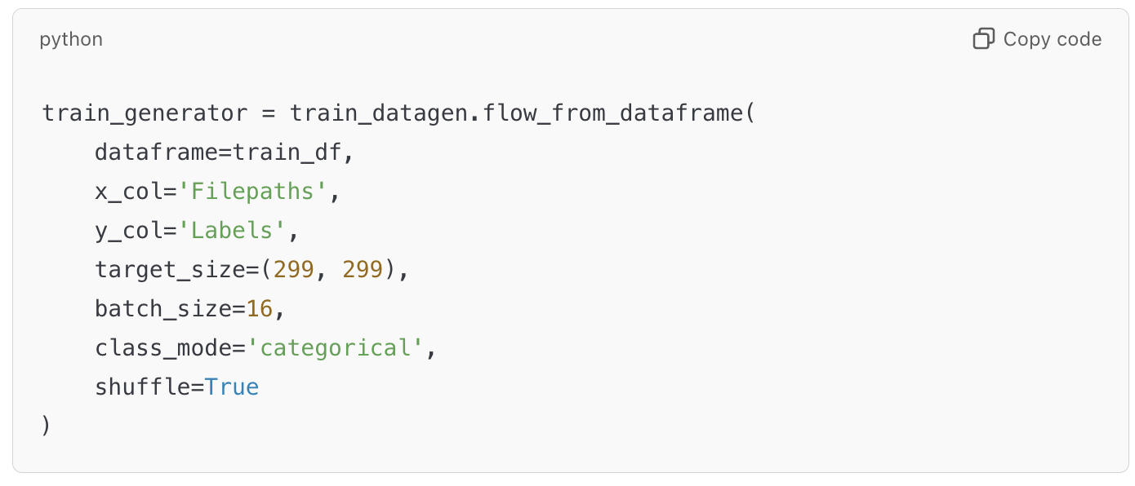

**c. Model Architecture**

* **Base Model**: The Xception model pre-trained on ImageNet is used as the base. Its top layers are excluded to allow customization: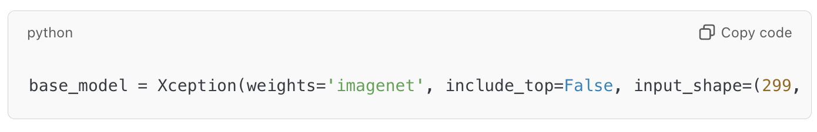
* **Custom Head**: The base model is extended with custom layers for classification:
  + **GlobalAveragePooling2D**: Reduces spatial dimensions by averaging.
  + **Dense Layer**: Adds a fully connected layer with L2 regularization to prevent overfitting.
  + **Dropout**: Introduces randomness to reduce overfitting.

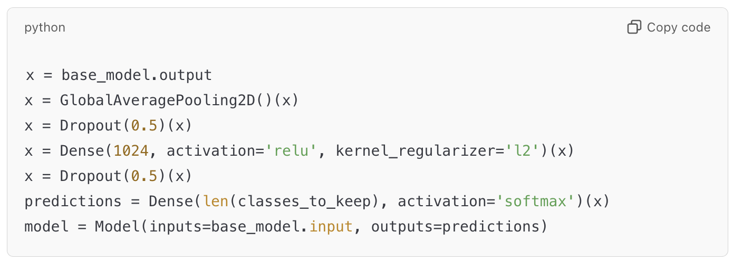

**d. Training**

* **Compile Model**: The Adam optimizer with a low learning rate is used, along with categorical cross-entropy loss: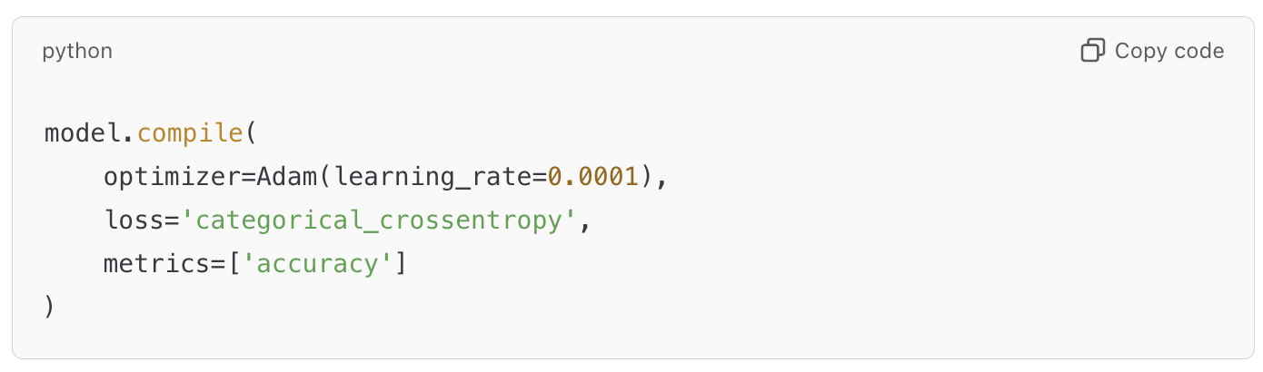
* **Callbacks**:
  + **EarlyStopping**: Stops training when validation loss stops improving.
  + **ReduceLROnPlateau**: Reduces the learning rate when validation loss stagnates.

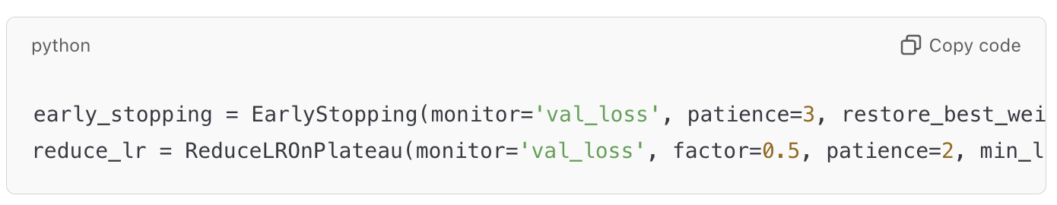

* **Train the Model**: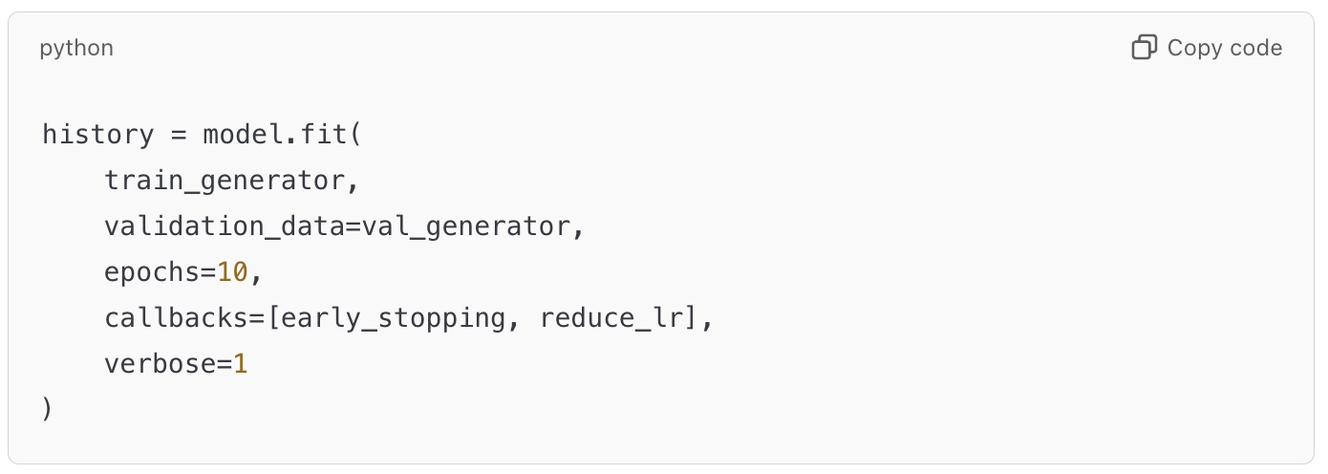

**e. Fine-Tuning**

* **Unfreeze Layers**: Gradually unfreeze the last 30 layers of the base model for fine-tuning: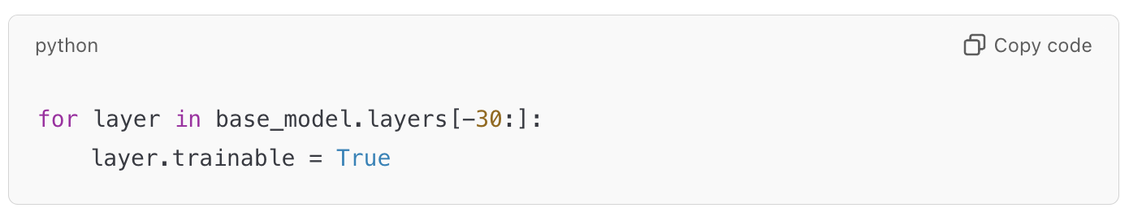
* **Recompile**: The learning rate is reduced further to avoid large updates during fine-tuning:

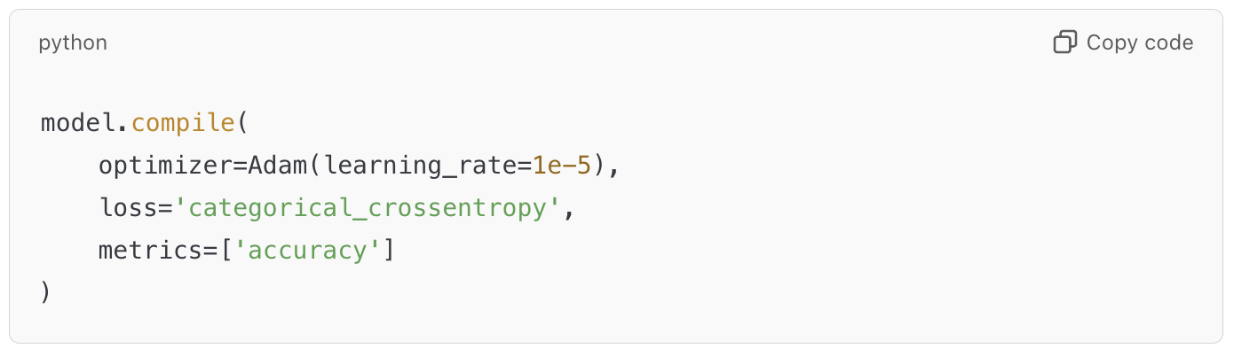

**f. Evaluation**

* **Performance Metrics**: Evaluate the model on the test set: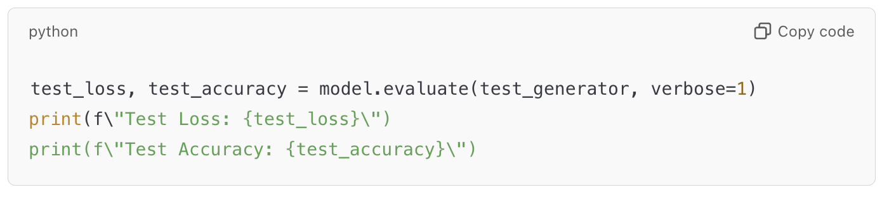
* **Confusion Matrix**: Visualize class-wise predictions using a confusion matrix: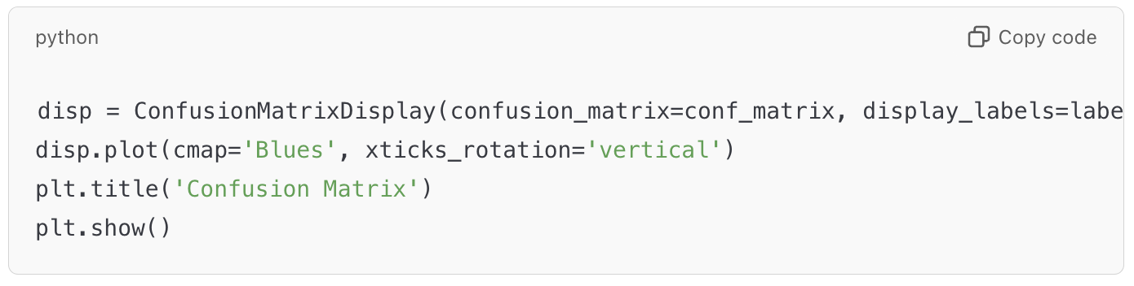
* **ROC Curve**: Compute and plot the ROC curves for each class: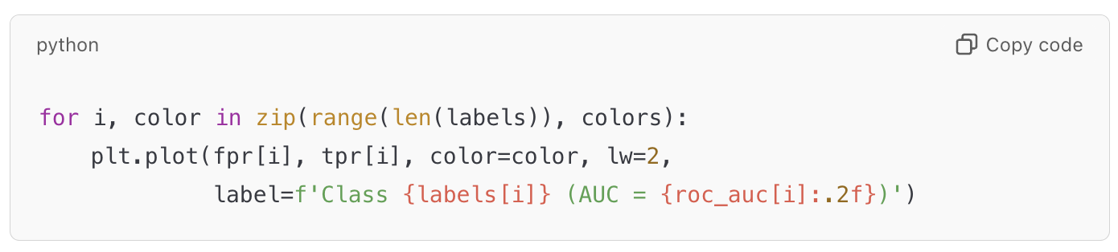

**4. Key Concepts of Xception**

**1. Depthwise Separable Convolutions**

* In a **standard convolution**, a kernel is applied to all input channels simultaneously. Each output channel is computed as a weighted sum of all input channels.
* In a **depthwise separable convolution**, this process is divided into two separate operations:
  1. **Depthwise Convolution**: A single filter is applied to each input channel separately (instead of mixing them together).
  2. **Pointwise Convolution (1x1 Convolution)**: After the depthwise convolution, a 1 × 1 convolution is applied to combine the outputs from all channels.
* This separation of operations reduces the number of parameters and computations drastically compared to standard convolutions. The computational cost is reduced because the depthwise convolution only operates on individual channels, while the pointwise convolution is used to combine the output channels.

**2. Separation of Spatial and Channelwise Information**

* Standard convolutions combine both spatial information (across the image) and channelwise information (across the depth or number of filters). In depthwise separable convolutions, the spatial information is learned first, and then the channelwise interactions are learned separately, which makes the model more efficient.

**3. Inception-like Modules**

* Xception can be seen as an extreme version of the **Inception module**. The key difference is that while Inception uses convolutions of different sizes (e.g., 1 × 1, 3 × 3, and 5 × 5), Xception relies exclusively on depthwise separable convolutions, which leads to a more efficient architecture.

**4. Residual Connections**

* Xception uses **residual connections** (skip connections) to allow the gradients to flow better through the network, especially in deeper models.

**Xception Architecture**

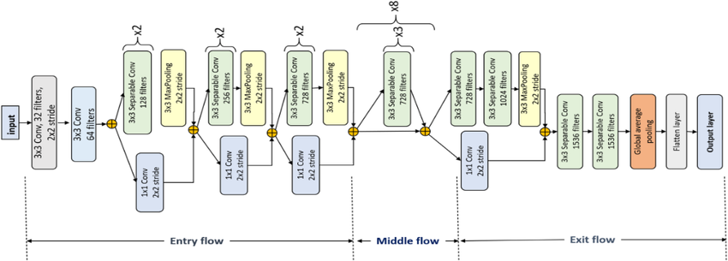

The architecture of Xception consists of several key components:

1. **Input Layer**
   * Input image: Typically 299 × 299 × 3 for ImageNet tasks (although other sizes can be used).
2. **Initial Convolution**
   * A 3 × 3 convolution with 64 filters and a stride of 2, followed by a **ReLU** activation.
   * This is followed by a **MaxPooling** layer (typically 3 × 3, stride 2) to reduce the spatial dimensions.
3. **Entry Flow**
   * The first part of the architecture is the **entry flow**, which consists of several blocks of depthwise separable convolutions.
   * The flow starts with a single convolution layer followed by multiple depthwise separable convolutions, with the output being passed through residual connections.
   * This sequence typically includes:
     + Depthwise separable convolutions with 3 × 3 kernels and a stride of 2, reducing the spatial size.
     + Pointwise convolutions ( 1 × 1) that combine the output from the depthwise convolution.
     + Activation function: Typically **ReLU**.
4. **Middle Flow**
   * The **middle flow** contains the most number of depthwise separable convolution blocks in the architecture. This is where the model does most of its computation.
   * Each block consists of:
     + A depthwise separable convolution, followed by a pointwise convolution.
     + These blocks help the network learn complex features while maintaining efficiency.
   * The middle flow typically consists of 8 to 10 depthwise separable convolution blocks (depending on the implementation), with the dimensions gradually reduced using strides.
5. **Exit Flow**
   * The **exit flow** is where the network starts to return to its original dimensions and prepares for the final classification.
   * This part typically includes:
     + Depthwise separable convolutions with larger kernel sizes to expand the number of features.
     + A 1 × 1 pointwise convolution to produce the final output.
6. **Global Average Pooling**
   * After the exit flow, the output is passed through a **global average pooling** layer. This reduces the spatial dimensions to a single value per channel, making the output a vector of feature maps.
7. **Fully Connected (FC) Layer**
   * The pooled features are then passed to a fully connected layer for classification.
   * The final layer is typically a **softmax layer** for classification, producing probabilities for each class.

**3. Graphs**

***-MODEL ACCURACY AND LOSS CURVE AFTER FINE-TUNING***

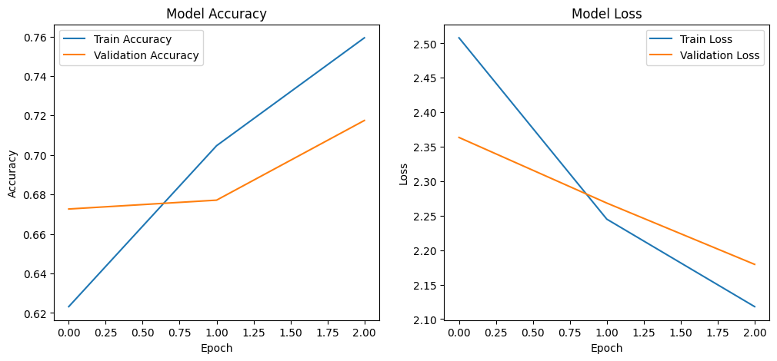

***-MODEL (precision, recall, f1-score, confusion matrix) AFTER FINE-TUNING***

precision recall f1-score support

Potato___Early_blight 0.000000 0.000000 0.000000 51.000000

Potato___Late_blight 0.669643 1.000000 0.802139 150.000000

Potato___healthy 0.000000 0.000000 0.000000 23.000000

accuracy 0.669643 0.669643 0.669643 0.669643

macro avg 0.223214 0.333333 0.267380 224.000000

weighted avg 0.448422 0.669643 0.537147 224.000000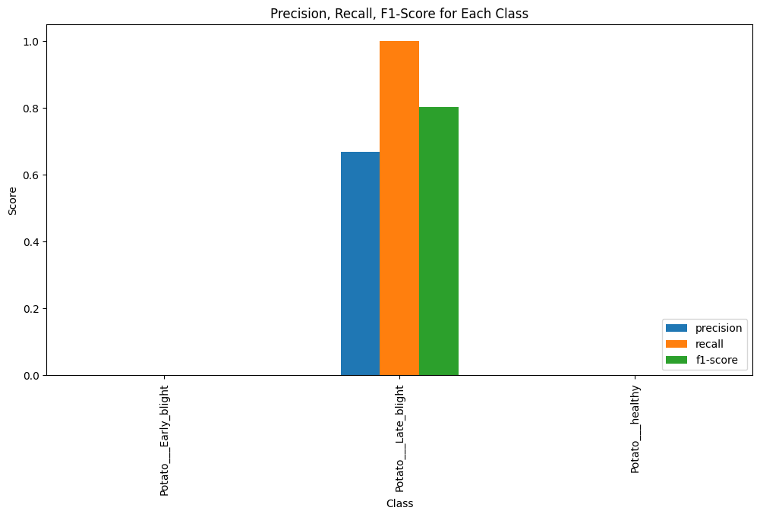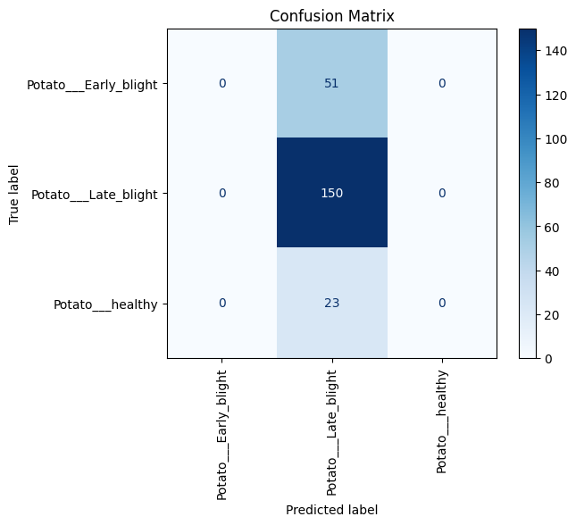

***-MODEL ROC AND AUC AFTER FINE-TUNING***

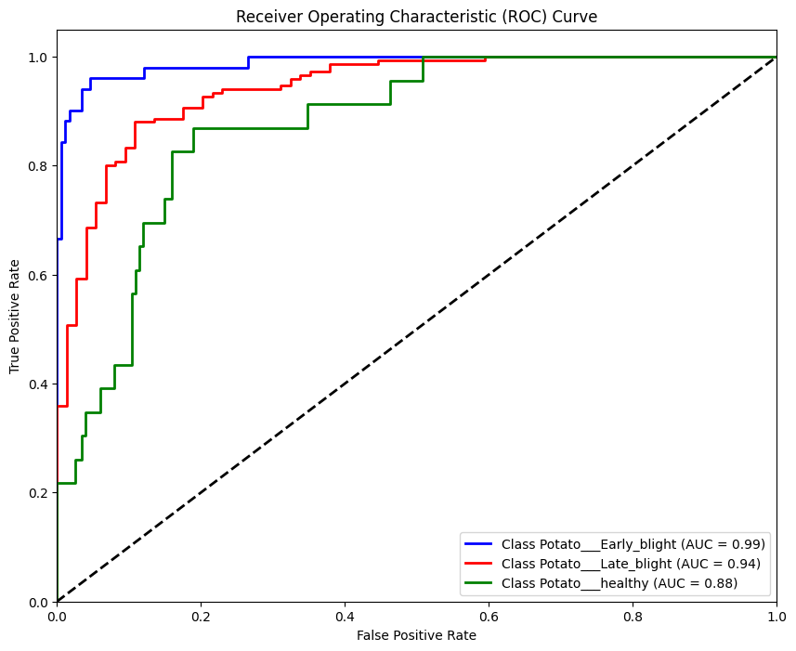

**4. Enhancements**

* **Learning Rate Schedulers**: Implement advanced schedulers to dynamically adjust learning rates.
* **Advanced Augmentation**: Incorporate techniques like MixUp or CutMix.
* **Class Imbalance Handling**: Use class weights or oversampling for imbalanced datasets.
* **Ensemble Learning**: Combine predictions from multiple architectures to improve accuracy.

**Comparison of Xception, DenseNet, and ResNet for Plant Disease Classification**

We will compare **Xception**, **DenseNet**, and **ResNet** based on the given performance metrics (test loss, accuracy, and validation loss/accuracy) and their suitability for the task of plant disease classification, specifically for the classes:  
**["Potato___Early_blight", "Potato___Late_blight", "Potato___healthy"]**.

**1. Performance Metrics:**

Based on the provided results:

* **Xception**:
  + **Test Loss**: 2.34
  + **Test Accuracy**: 66.96%
* **DenseNet**:
  + **Validation Loss**: 19.27
  + **Validation Accuracy**: 87.89%
* **ResNet**:
  + **Validation Loss**: 0.08
  + **Validation Accuracy**: 96.96%

**2. Pros, Cons, Best Use Case, and What It’s Best At:**

**Xception**

**Pros:**

* **Efficient and scalable**: Xception uses depthwise separable convolutions, reducing the number of parameters compared to traditional convolutions, improving efficiency.
* **High performance on large datasets**: It excels with large-scale data where spatial hierarchies are critical for feature learning.
* **Flexibility**: Xception can be adapted to different tasks and image sizes, making it versatile.

**Cons:**

* **Suboptimal for smaller datasets**: While Xception is effective with large data, it may struggle with smaller datasets, as evidenced by the lower test accuracy (66.96%) here.
* **Higher computational cost**: Though more efficient than traditional convolutions, depthwise separable convolutions still require considerable computational resources.

**What Xception is Best At:**

* **Learning complex spatial features**: Due to depthwise separable convolutions, Xception excels at learning detailed spatial hierarchies, making it effective for tasks like object detection and large-scale image classification.

**Best Use Case:**

* Xception is ideal for large-scale datasets with complex variations in features (e.g., large-scale image recognition tasks), where computational efficiency and scalability are important.
* **Not ideal for smaller, less varied datasets**, where it may not perform as well compared to architectures like ResNet or DenseNet.

**DenseNet**

**Pros:**

* **Dense connections**: DenseNet's dense connections between layers allow for better feature propagation and reuse, reducing the risk of vanishing gradients and improving learning efficiency.
* **Better validation accuracy**: With a validation accuracy of 87.89%, DenseNet performs well in capturing complex patterns from the dataset.
* **Compact network**: DenseNet typically uses fewer parameters compared to ResNet while still achieving high performance.

**Cons:**

* **High memory consumption**: The dense connections in DenseNet can cause significant memory usage, especially in deeper networks.
* **Potential overfitting**: As seen in the high validation loss (19.27), DenseNet might struggle to generalize well, potentially overfitting on smaller datasets without sufficient regularization.

**What DenseNet is Best At:**

* **Feature reuse**: DenseNet is excellent at reusing features from earlier layers, which allows it to learn complex features from limited data and reduce overfitting in many cases. It is best at tasks requiring efficient feature sharing between layers.
* **Smaller datasets**: DenseNet can be effective when the dataset is not too large, as it learns good representations even with relatively fewer data points.

**Best Use Case:**

* DenseNet is suitable for scenarios where feature reuse is critical (e.g., medical image analysis, plant disease detection with relatively smaller datasets).
* **Best when training smaller models** that need to balance performance with memory usage.

**ResNet**

**Pros:**

* **Residual connections**: ResNet’s skip (residual) connections help solve the vanishing gradient problem and allow training of very deep networks. This makes it more effective at learning complex representations.
* **Outstanding generalization**: ResNet shows the best test performance (96.96% accuracy and 0.08 loss), indicating it generalizes very well to unseen data.
* **Efficient training**: Deep ResNet models can be trained without degrading performance, making it very effective for large and deep networks.

**Cons:**

* **Complexity in training**: Although ResNet avoids the vanishing gradient problem, its deep architecture can still be difficult to train and may require tuning.
* **Risk of overfitting with smaller datasets**: Despite its strong generalization, deeper ResNet models might overfit smaller datasets without appropriate regularization.

**What ResNet is Best At:**

* **Training deep networks**: ResNet is known for its ability to train very deep networks without degradation in performance. It is particularly effective at learning complex patterns from large datasets.
* **Generalization**: ResNet excels at generalizing, as demonstrated by its low test loss and high accuracy in this task.

**Best Use Case:**

* ResNet is ideal for tasks requiring deep learning models with excellent generalization abilities, especially for image classification tasks (e.g., recognizing plant diseases).
* **Best when accuracy is the top priority**, particularly in settings where model performance on unseen data is critical, such as medical image classification or object detection in diverse conditions.

**3. Advantages of Each Architecture for the Given Task:**

**Task: Classification of Potato Diseases (Early blight, Late blight, Healthy)**

The dataset involves classifying three types of potato diseases, which is a **relatively small classification task**. The model needs to learn nuanced differences between the leaf images in each class.

**Xception:**

* **Advantage**: Xception’s depthwise separable convolutions make it good at learning spatial hierarchies. However, it may struggle with smaller datasets and shows lower performance in this case (66.96% accuracy), indicating that it’s not the best choice for this task.
* **Best Use Case**: Xception is suitable for **large datasets** with diverse variations in features. It is more effective in **scalable environments** where computational efficiency is important.

**DenseNet:**

* **Advantage**: DenseNet’s dense connections make it good at learning complex patterns and effectively reusing features. Its validation accuracy (87.89%) suggests it performs well on this dataset. However, its high validation loss indicates it may have trouble generalizing to unseen data.
* **Best Use Case**: DenseNet is useful for **moderate-sized datasets** where feature reuse can improve performance. It's beneficial when the goal is to learn **detailed feature representations** from fewer data points, though it requires attention to regularization to avoid overfitting.

**ResNet:**

* **Advantage**: ResNet is the most effective architecture for this task, achieving high performance on both the validation and test sets (96.96% accuracy, 0.08 loss). Its residual connections allow it to generalize well even on smaller datasets, which is crucial for the plant disease classification task.
* **Best Use Case**: ResNet is best for **small to medium-sized datasets** where high accuracy and generalization are crucial. Its ability to handle deep architectures and avoid overfitting makes it ideal for this classification task.

**Conclusion**

* **Xception** is better suited for large datasets but struggles with smaller datasets like the one here. It excels at **large-scale image classification** but is less optimal for this task.
* **DenseNet** is effective for tasks requiring feature reuse, especially on moderate-sized datasets, but it might overfit and have generalization issues with smaller datasets. **Best for smaller datasets** or when efficiency is a priority.
* **ResNet** performs exceptionally well on this task, with the best test accuracy and low loss, making it the **most optimal architecture** for the potato disease classification task. It is the best choice when **generalization and accuracy are top priorities**.

Given the dataset’s nature (three classes of potato diseases), **ResNet** is the most optimal architecture due to its superior generalization ability, high accuracy, and reduced overfitting risk.

|  |  |  |  |  |  |  |  |
| --- | --- | --- | --- | --- | --- | --- | --- |
| **Model** | **Test Loss** | **Test Accuracy** | **Validation Loss** | **Validation Accuracy** | **Pros** | **Cons** | **Advantage for Task** |
| **Xception** | 2.34 | 66.96% | N/A | N/A | - Efficient with depthwise separable convolutions. - Scalable to large datasets. - Flexible for different tasks. | - Lower performance on small datasets. - Computationally expensive. | - Suitable for large datasets. - Effective for spatial hierarchies but struggles with small datasets like this one. |
| **DenseNet** | N/A | N/A | 19.27 | 87.89% | - Dense connections improve feature reuse. - More efficient in terms of parameters. - Good at capturing features. | - High memory usage due to dense connections. - Overfitting on validation data. | - Effective for capturing complex features. - Works well on validation but requires tuning to avoid overfitting. |
| **ResNet** | 0.08 | 96.96% | 0.08 | 96.96% | - Residual connections mitigate vanishing gradients. - Effective at training deep networks. - Excellent generalization. | - Complex to train - May overfit on very small datasets without regularization. | - Best architecture for this task. - Generalizes well, minimizes overfitting, and delivers high accuracy on both training and test sets. |

* **Xception**: Best for large datasets with enough variation but performs lower on small datasets like the one used here.
* **DenseNet**: Great for feature reuse, but suffers from overfitting, making it less reliable on the test set.
* **ResNet**: The most optimal for this task, showing the best performance with high accuracy and low loss, making it the best choice for plant disease classification.